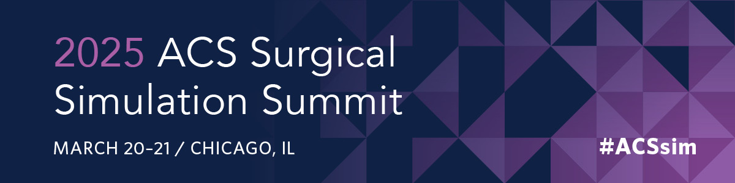

**Attendee Justification Letter for Approval to Register for the 2025 ACS Surgical Simulation Summit**

Dear [Fill in Blank]

I would like to register to attend the 18th Annual ACS Surgical Simulation Summit —an international, multiprofessional meeting devoted to discussing the latest advances in simulation-based surgical education, sharing best practices, and presenting innovative research. The 2025 Summit takes place March 20 – 21, in Chicago, IL.

**Audience for the ACS Surgical Simulation Summit**

The audience includes leaders of accredited simulation centers, surgeon educators, anesthesiologists, health professionals, simulation experts, professional educators, engineers, and surgical trainees. The opportunities to network are plentiful and foster camaraderie among members of the ACS-AEI Consortium and the broader simulation community.

**2025 Educational Program**

The Summit begins on Thursday with the annual update on the ACS-AEI Consortium, followed by the Keynote Address from Dr. Henri Ford, MD MHA, FACS, Dean and Chief Academic Officer of the University of Miami Miller School of Medicine and Immediate Past President of the American College of Surgeons.

Afterwards, I am given the option of attending the Scientific Paper Sessions or the Management, Operations, Research, and Education (MORE) Track sessions about using data to your advantage/ demonstrating ROI; building, maintaining, and celebrating your simulation team; and diversification of resident skills practice. In the afternoon, a “Meet the Authors” Poster Session will occur followed by a panel about increasing the impact of your ACS Accredited Education Institute (AEI).

On Friday morning, concurrent workshops are offered covering a wide range of relevant topics and I plan on attending [Fill in Blank]. Afterwards, Special Interest Groups (SIGs) will give me the opportunity to meet with individuals in similar roles for facilitated discussion and networking. Next, topic-based SIGs will bring together attendees sharing common interests to share insights, resources, and ideas. I would like to attend the SIG on [Fill in Blank].

In the afternoon, there is a special session with the American Society of Anesthesiologists (ASA) which will include presentations from the winners of the ACS/ASA Joint Quality and Safety Challenge. Discussions on how to use simulation to address quality improvement at our institution will follow.

To review the full program, please visit <https://www.facs.org/for-medical-professionals/conferences-and-meetings/surgical-simulation-summit/>

**Continuing Education**

I will earn CME credits or Completion credits for attending all sessions. The conference offers an outstanding blend of education, innovation, practice, and inspiration for everyone involved in delivering simulation-based surgical education. I will learn about solutions and best practices related to our field, plus the latest science, and network with peers, industry leaders and innovators. I look forward to sharing this knowledge with my colleagues.

**Costs**

I am requesting funding for: [Fill in Blank].

**Conference Fees:** $770 for Non-AEI Members

**Food:** (Breakfast, lunch, networking reception on Thursday and breakfast and lunch on Friday are included in the registration fee.)

**Lodging:** (Special room rate of $245.00 + tax/night are available at the Swissotel Chicago until February 25, 2025.)

**Travel Costs:** [Fill in Blank]

This meeting offers an important educational experience, which will greatly benefit our organization.

Thank you for your time and consideration. Please let me know if there is any additional information I can provide to assist in your decision.

Sincerely,

[Fill in Blank]